Modern Slavery and Human Trafficking Statement
Financial Year Ending: 31 January 2026

1. Introduction
Penta-A Services Limited is committed to preventing modern slavery and human trafficking in all aspects of its business and supply chains. This statement is made pursuant to Section 54 of the Modern Slavery Act 2015 and outlines the steps taken during the financial year ending 31 March 2026.
2. Organisation Structure, Business and Supply Chains
Penta-A Services Limited is a domiciliary care provider operating in the United Kingdom. The organisation delivers care services to individuals in their own homes and works with suppliers including recruitment agencies, training providers, and equipment suppliers.
3. Policies in Relation to Modern Slavery
We operate a number of internal policies to ensure ethical conduct, including Safeguarding Policy, Recruitment Policy, Equal Opportunity Policy,Whistleblowing Policy, and Code of Conduct. These policies reinforce our zero-tolerance approach to modern slavery.
4. Due Diligence Processes
We carry out due diligence on all staff and suppliers, including right-to-work checks, DBS checks, reference verification, and supplier approval processes. Suppliers are expected to comply with relevant legislation and ethical standards.
5. Risk Assessment and Management
We recognise that risks may arise in recruitment and supply chains. These risks are mitigated through strict recruitment controls, staff monitoring, and supplier checks.
6. Effectiveness and Performance Indicators
We monitor effectiveness through training completion rates, safeguarding reports, recruitment compliance, and internal audits. Our target is 100% compliance with mandatory training and recruitment checks.
7. Training and Awareness
All staff receive training on safeguarding and recognising signs of modern slavery. Training is provided at induction and refreshed annually.
8. Reporting Concerns
Staff are encouraged to report concerns via management or whistleblowing procedures. All reports are investigated promptly and handled confidentially.
9. Approval
This statement has been approved by senior management and will be reviewed annually.
Signed:
Name: Abiola Badejo
Position: Registered Manager / Director
Signature: 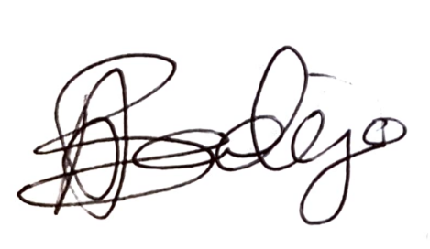

Date: 28/04/26

Our Modern Slavery Statement is reviewed and updated annually, with the next review scheduled for March 2027.

